**ASSIGNMENT 4**

Name : Prachi garg

Roll no. : 15544

Class : Bsc 1

Q 1 : Write a program to list out the first n fibonnacci numbers.

Ans 1 :

#include<iostream.h>

#include<conio.h>

int fib(int last,int next,int limit)

{

cout<<last<<" ";

long sum =next+last;

next=last;

last=sum;

if(next>limit/2)

return 0;

else

return fib(last,next,limit);

}

int main()

{

clrscr();

int limit;

int next=0;

int last=1;

cout<<"Enter the number till you want fibonicci number : ";

cin>>limit;

fib(last,next,limit); //15544

getch();

return 0;

}

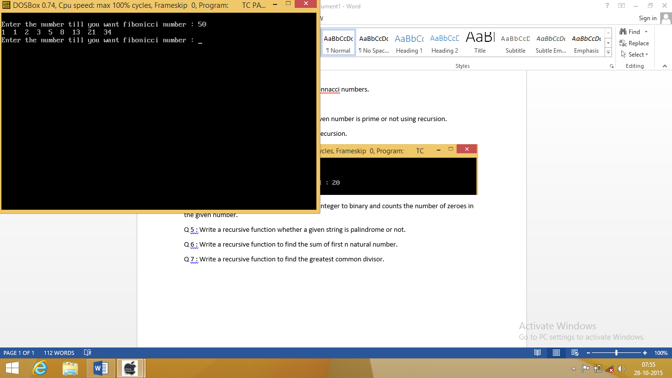

Q 2 : Write a program to check whether the given number is prime or not using recursion.

Ans 2 :

#include<iostream.h>

#include<conio.h>

#include<process.h>

int prime(int n, int i)

{

if(n%i==0)

return 1;

else if (i==n-1 && (n%i)!=0)

return 0;

else

prime(n,i+1);

}

int main()

{

clrscr();

int n;

int i=2;

cout<<endl<<"Enter the number : ";

cin>>n;

if(n<=1)

{

cout<<"Wrong input"<<endl;

exit(0);

}

if(prime(n,i))

cout<<"Not a prime number"<<endl; //15544

else

cout<<"It is a prime number "<<endl;

getch();

return 0;

}

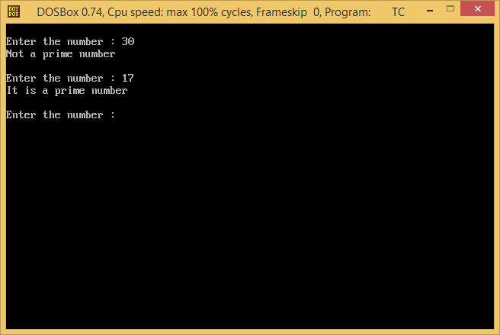

Q 3 : Write a program for binary search using recursion.

Ans 3 :

#include<iostream.h>

#include<conio.h>

int binary(int a[],int x,int last,int first)

{

int mid=(first+last)/2;

if(x==a[mid])

{ return mid+1;

}

else if(x<a[mid])

{ last=mid-1;

return binary(a,x,last,first);

}

else if(first==last && x!=a[mid])

return 0;

else

{ first=mid+1;

return binary(a,x,last,first); //15544

}

}

int main()

{

int n;

int a[20];

cout<<"How many elements in the array : ";

cin>>n;

cout<<"Enter the array"<<endl;

for(int i=0; i<n; i++)

cin>>a[i];

cout<<"Enter the no. which you want to find : ";

int x;

cin>>x;

int mid;

int first=0;

int last=n-1;

int p=binary(a,x,last,first);

if(p==0)

cout<<"Number is not in the list"<<endl;

else

cout<<"Number found at "<<p<<" position"<<endl;

getch(); //15544

return 0;

}

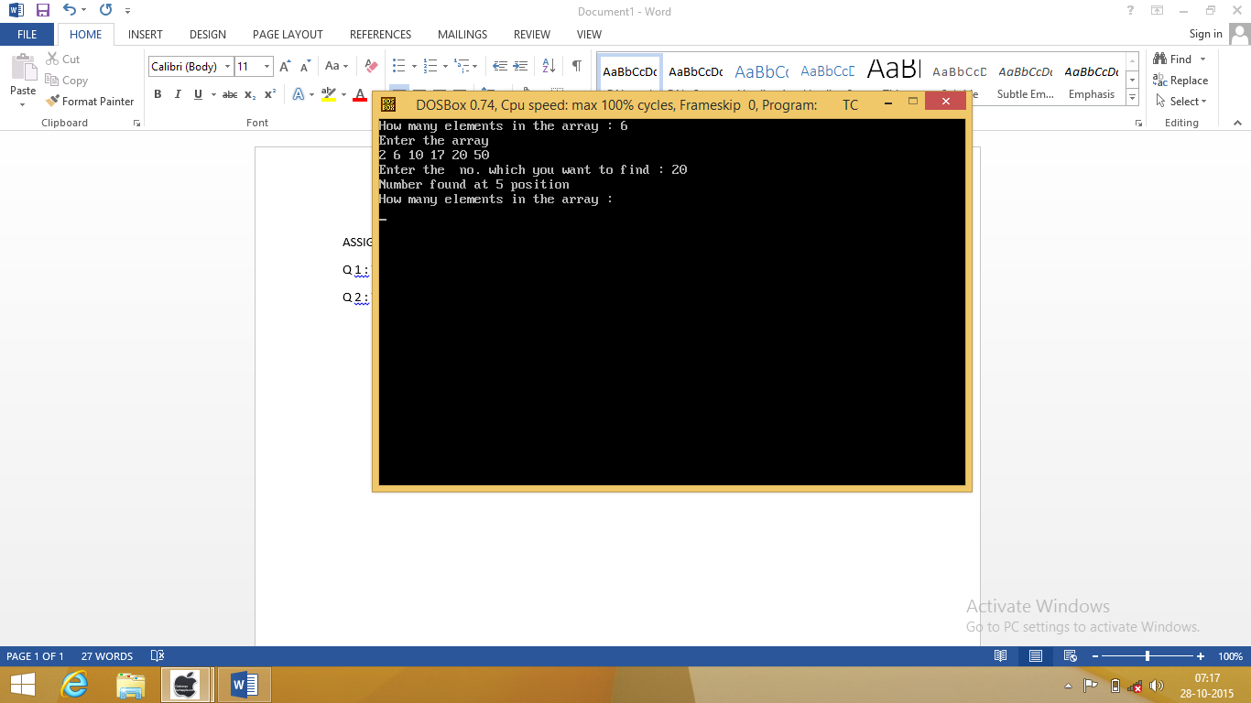

Q 4 : Write a program that converts the given integer to binary and counts the number of zeroes in the given number.

Ans 4 :

#include<iostream.h>

#include<conio.h>

int dtob(long n,int sum ,int i)

{

int r;

r=n%2;

sum=sum+(i*r);

n=n/2;

if(n==0)

return sum;

else

{

i=i*10;

return dtob(n,sum,i);

}

}

int main()

{

clrscr();

long n;

int i=1;

cout<<endl<<"Enter the number : ";

cin>>n;

int sum=0;

cout<<"The binary number is : "<<dtob(n,sum,i);

cout<<endl<<"The sum of zeroes is : "<<sum;

getch(); //15544

return 0;

}

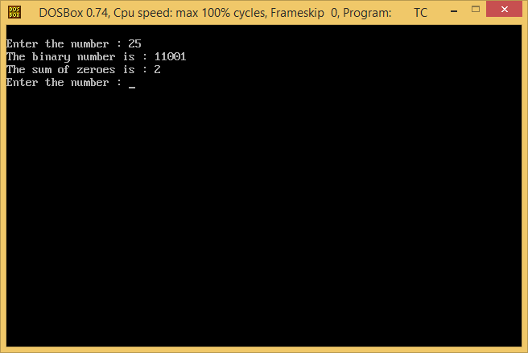

Q 5 : Write a recursive function whether a given string is palindrome or not.

Ans 5 :

#include<iostream.h>

#include<string.h>

#include<conio.h>

int pelindrom(char a[30],int i,int j ,int limit)

{

if(limit%2!=0)

{

if(a[i]!=a[j])

return 0;

else if (j==i && a[i]==a[j])

return 1;

else

return pelindrom(a,i+1,j-1,limit);}

else

{

if(a[i]!=a[j])

return 0;

else if (i=(limit-1)/2 && j==i+1 && a[i]==a[j])

return 1;

else

return pelindrom(a,i+1,j-1,limit);

}

} //15544

int main()

{

clrscr();

char a[30];

int i=0;

int j;

cout<<endl<<"Enter the string"<<endl;

cin.getline(a,30);

int limit=strlen(a);

j=limit-1;

int b=pelindrom(a,i,j,limit);

if (b==1)

cout<<"It is a palindrome"<<endl;

else

cout<<"Not a palindrome"<<endl;

getch(); //15544

return 0;

}

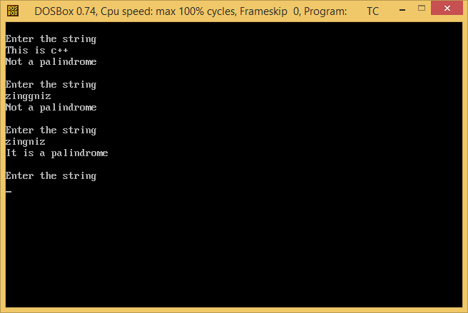



Q 6 : Write a recursive function to find the sum of first n natural number.

Ans 6 :

#include<iostream.h>

#include<conio.h>

int sum(int x)

{

if(x==0)

return 0;

else

return x+sum(x-1);

}

int main()

{

clrscr();

int numb;

cout<<"enter the number till you want the sum\n";

cin>>numb;

cout<<"sum: "<<sum(numb);

getch(); //15544

return 0;

}

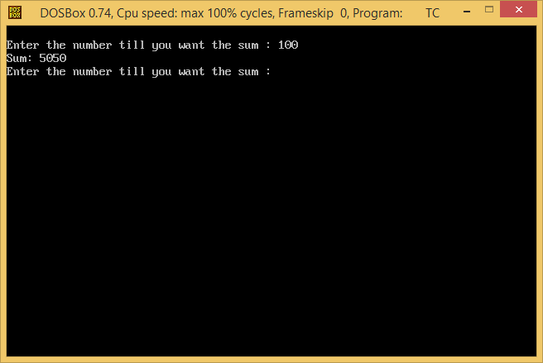

Q 7 : Write a recursive function to find the greatest common divisor.

Ans 7 :

#include<iostream.h>

#include<conio.h>

int gcd(int x,int y)

{

if(x % y==0)

return y;

else

return gcd(y,x % y);

}

void main()

{

clrscr();

int i,j,k; //15544

cout<<endl<<"Enter integer 1 : ";

cin>>i;

cout<<"Enter integer 2 : ";

cin>>j;

k= gcd(i,j);

cout<<"The greatest common divisor of these number's is : "<<k;

getch(); //15544

}

